
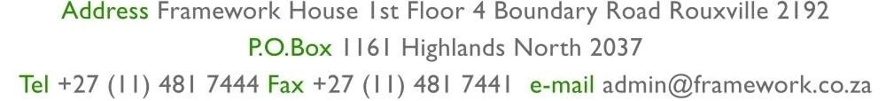
LANDLORD  VAT REG. NO.  INVOICE NUMBER | MR. T.W. MOKOTEDI  N/A  1120ILSTS/122/2
Rwubatswenimana Isaac
Unit 122
Glencairn Building
73 Albertina Sisulu, Johannesburg
Johannesburg
2001
VAT REG: N/A

UNIT
BUILDING
REFERENCE NO.
MONTH
07/2025
ILSTS/122/2

Glencaim

122

This document reflects transactions up to 26 July 2025
Landlord Deposit: 0.00
Deposit held: -32.00
Date | Reference | Details |  |  | Amount |  | Vat |  | Total incl. VAT
 | 06/2025 | Previous O/Balance |  |  | 0.00 |  | 0.00 |  | 32.83
2025/07/25 | 06/2025 | Opening Balance - July 2025 |  |  | 0.00 |  | 0.00 |  | 53.38
2025/07/25 | 6664449-2 | Rent |  |  | 0.00 |  | 0.00 |  | 6 055.00
2025/07/25 | 6659769-1 | Cash Deposit Fee - Cash Deposit Invoice |  |  | 0.00 |  | 0.00 |  | 37.00
2025/07/25 | 6659940-19 | Late Payment Fee - Admin Fee |  |  | 0.00 |  | 0.00 |  | 50.00
2025/07/25 | 6664275-1 | Interest |  |  | 0.00 |  | 0.00 |  | 40.17
2025/07/25 | 6664449-3 | Water |  |  | 0.00 |  | 0.00 |  | 263.07
2025/07/25 | 6664449-1 | Basic Facility |  |  | 0.00 |  | 0.00 |  | 20.00
2025/07/25 | 6667299-65 | Water - Invoice Process |  |  | 0.00 |  | 0.00 |  | 191.34
 |  |  | Totals | 0.00 |  | 0.00 |  | 6 709.79
Remarks:
Please Note: Reminder - From 28 November 2025 we no longer provide hand delivery statements,
ALL statements to be forwarded electronically

Bank Details: Bank: Absa; Account: 4091705716; Branch: Sandton ; Branch Code: 632005
Bank Reference: ILSTS/122/2
Date Printed 24/07/2025 Page no. 1 of 1
Powered by Propsys Solutions: 0861113406

